Web Based Document Management of Sessions Archive in Higher Education Institution

D. Tomin, Lj. Kazi, and B. Radulovic
University of Novi Sad, Technical faculty “Mihajlo Pupin”, Zrenjanin, Serbia
gaga_18d63@gmail.com, leremic@tfzr.uns.ac.rs, bradulov@tfzr.uns.ac.rs

Abstract – Document management in public institutions is very important, particularly for educational institutions. This paper presents research in the field of document management systems and describe developed web application for the support of sessions documents archive.

Introduction
Information technologies (IT) support document management in various ways. With development of new IT solutions, constant improvements are made in all segments of business and public sector organizations. There is no doubt that using IT in document management has many benefits. It improves business processes and enables cost savings.
This paper presents research in the field of document management benefits and systems. It also presents a developed solution for the purpose of storage and retrieval of data regarding sessions documents archive. At educational institutions, sessions are organized as meetings of teaching, scientific and administrative staff where certain decisions are made. It is very important to record these decisions, in aim to enable staff to work according to these decisions. The developed solution is web application that enables storing data about sessions/meetings as well as organizing meetings and upload files regarding records on meetings’ conclusions. This system is developed particularly according to the needs of Technical Faculty “Mihajlo Pupin” Zrenjanin, University of Novi Sad (TFZR), but it could be used for any educational or public sector institution.

Electronic document management benefits
IT supported document management is also called “Electronic document management” (EDM) or “Document Management System” (DMS). This term is defined in [1] with particular words description:
- “Electronic: the use of modern information technologies
- Document: a set of information pertaining to a topic, structured for human comprehension, represented by a variety of symbols, stored and handled as a unit.
- Management: creation, storage, organization, transmission, retrieval, manipulation, update, and eventual disposition of documents to fulfill an organizational purpose.” [1]
The roles that documents have within organization are [1]:
- To record or to "document" contracts and agreements
- To record policies, standards, and procedures
- To represent a view of reality at a point in time (reports and plans)
- To create an image or impression
- To generate revenue as a product
- To support revenue by adding value to a product
- To act as a mechanism for communication and interaction among people and groups
- To act as a vehicle for organizational process
- To provide a discipline for capture and articulation of concepts and ideas

There are many benefits of using EDM. Benefits of their applications include [1]: Improving the publishing process, supporting and improving organizational processes (upgraded, "reengineered" basic business processes), Improved management and communication of concepts and ideas, Supporting communication among people and groups, Improving access to external information, Creating and maintaining documentation, (Leveraging Organizational Memory, Maintaining corporate records), promoting training and education.

Benefits of using document management systems are presented as tangible and intangible [2]. “Tangible benefits are those things that can be measured in the sense that the benefit can be quantified. Intangible benefits are things that are going to be hard to measure and attribute to the use of a DMS, but are nevertheless known benefits that occur indirectly through the implementation of a DMS.
- Tangible benefits would include: Reduced Storage, Flexible Retrieval, Flexible Indexing, Improved, faster and more flexible search, Controlled and Improved Document distribution, Improved Security, Disaster Recovery, No Lost Files, Digital Archiving, Improved Regulatory Compliance, Improved Cash Flow.
- Other less 'tangible' benefits of a DMS might include: Improved Internal Operations, Competitive Edge, Improved customer service and satisfaction, Preserve Intellectual Capital - Organizational Knowledge.” [2]
Other benefits also include [3]: document filling flexibility, saving time to file similar data to many document types, consistency of filling data, ability to share documents, improved documents organization and retrieval, cost and space savings, as well as [4]: enhanced security, secure back-ups, simplified routing (i.e. version control, document flow and quality control), and also [5] improvement of collaboration and standardization support. Of course, paperless office also improves ecology (green) initiatives implementation within institutions.

Document management systems functionality and architectures
Some professional IT companies develop software solutions for enterprise document management support, such as Thought Green Technologies [6]. Functionality of the system developed by this company is presented at Figure 1.

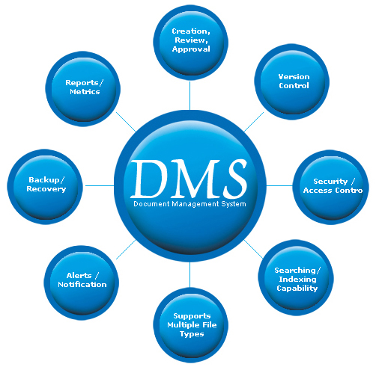
- Functionality of DMS from [6]
One of proposed architectures of integral DMS is presented at Figure 2.

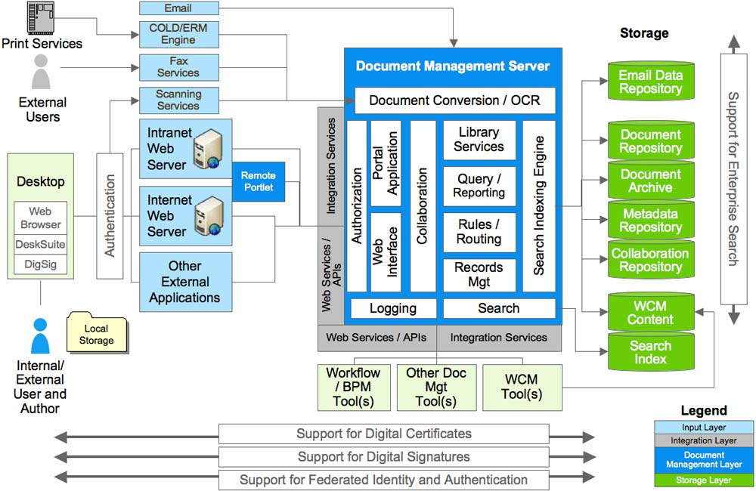
- Architecture pattern for DMS system [7]

Internet based document management systems are proposed by some US patents, such as [8].

Development of web based document management systems at TFZR

Initiative for the development of web based document management at TFZR started many years ago, but the implementation of such system started in March 2014. In that period two projects started with Ljubica Kazi as mentor and Biljana Radulovic as co-mentor:
- “Legal Docs @ TFZR” – document management system for archive and retrieval of legal documents at TFZR, author: Miodrag Seslija [9]
- “Sessions Archive @ TFZR” – document management system for sessions records archive, author: Dragana Tomin.
These two document management systems are similar and both in verification and testing phase, so they could be improved and installed at TFZR.
First system, “Legal Docs” is oriented towards uploading and publication of documents at official web page of TFZR (www.tfzr.uns.ac.rs). Documents are related to legal regulations, procedures and forms. User interface of existing static list of links with documents is replaced with dynamically created table that retrieves data from database, related to the approved documents.
Second system is oriented particularly to organization of meetings (sessions) and publication of documents with records about meetings conclusions.

Sessions document management at TFZR – the status at project start
By sessions we consider meetings of teaching, scientific and administrative staff at a higher education institution. The sessions are important, since all decisions regarding procedures, finance and work engagements are agreed in dialog of all meeting participants. There are several types of sessions/meeting:
- Meeting of all staff
- Meeting of department staff
- Meeting of deans advisory board
- Meeting of conference organizing committee
- etc.
At the project starting, current state at TFZR regarding sessions records and archive regarding meeting of all staff and meeting of department staff was:
1. Session announcement - all teaching, scientific and administrative staff receive announcement of meeting by e-mail. List of proposed topics for discussion is enclosed as attachment with this e-mail, but also printed and put at information board next to the dean’s office
2. Session decisions recording – during sessions, a secretary takes notes about all relevant decisions. After the session finishes, the secretary enters all the notes in MS Word form and prints several copies, for the archive.
3. Document distribution – at the time of next session announcement, document with previous session conclusions and decisions are distributed to all staff, in aim to accept the records during the next session. At the beginning of the next session, each staff member is to decide if he/she accepts records within that document about previous session conclusions.

Development of new DMS for sessions archive at TFZR

Based on previously presented benefits of EDM, initiative for development of new, web based system for document management, particularly in the field of sessions organization and records has started.
Activities in development of such system were:
1. Determination of regulations regarding electronic document management, as well as regulations regarding sessions organization at TFZR and University of Novi Sad,
2. Use case design, where all potential users and the available functionality of software were determined as actors (i.e. user types):
- Administrator – defines types of sessions and assigns staff to particular session type to secretary position
- Meeting secretary – announces meeting, generates session records (upload file with document about meeting conclusions)
- Staff – tabular overview with all session records, from different session types, as well as filtering of data
3. Conceptual data modeling – there are 4 entities, i.e. database tables: Session type, Session, Records Document, Suggested topic (Figure 3).

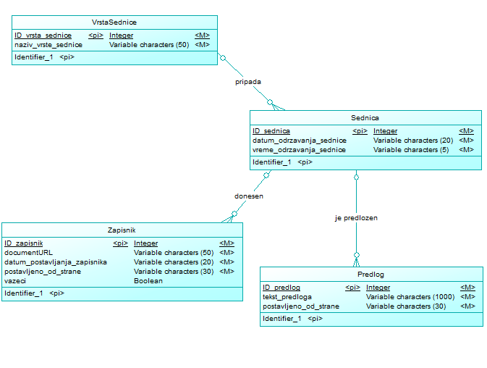
- Conceptual data model for sessions DMS
4. Database creation - Database is created in SQL Server 2008, by using SQL script generated from Sybase Power Designer CASE tool, based on conceptual data model and physical data model.

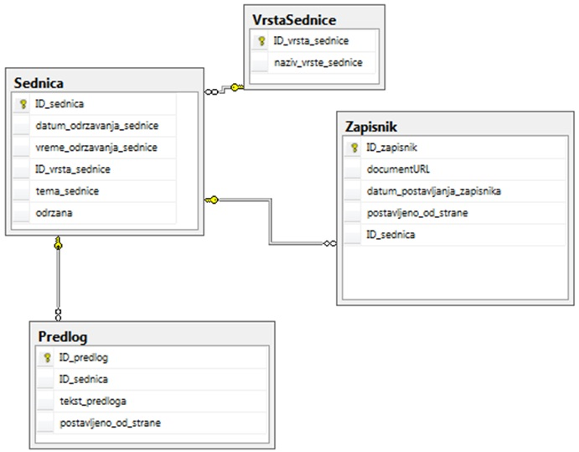

- MS SQL Server database diagram
4. User interface design – Web application is designed within MS Visual Studio .NET 2010 as ASPX application. For each user type (i.e. actor) there was a separate master page with appropriate items at navigation menu.

Figure 5. presents session announcement web page. At this page secretary of appropriate meeting could enter data about upcoming meeting – selecting session type, main topic, date and time of meeting start.

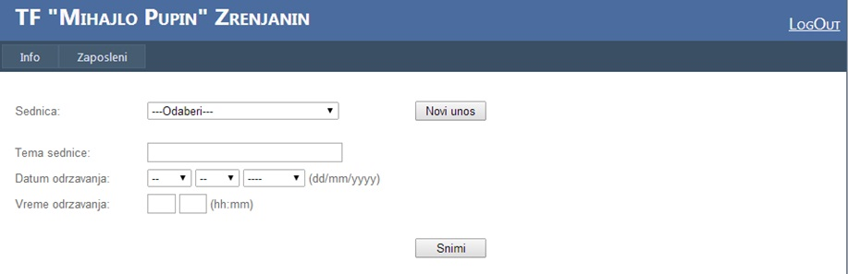

- Session announcement page
Figure 6. presents document record upload page. Secretary selects particular session that was previously entered as announced, enters data about meeting finalization and uploads file with documents containing records about meeting.

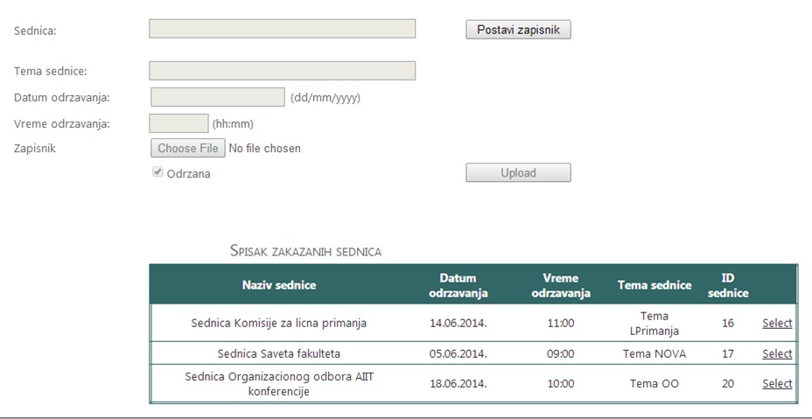
- Meeting records document upload page
Finally, at Figure 7. There is a table with list of all documents from different session types. When a regular staff member log –in, he/she could start page with this list and download the document, in aim to consult and apply conclusions and decisions from particular session.
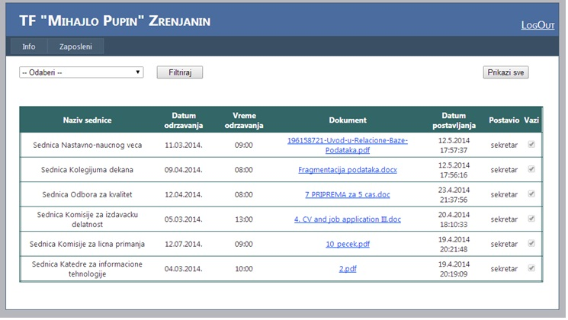
- List of uploaded documents as session records
5. Programming – all the programming was made with C# programming language. Connections to database are made by using standard SQL Client classes, such as SQL Connection, SQL Command etc. Communication between pages was performed by using Sessions. Data tables are connected to SQL Data Source, in aim to enable better design of table columns.

Conclusion
Electronic document management or document management systems that are supported by information technologies enable improvement of efficiency of business processes as well as cost savings, with additional ecology impact, of course.
This paper presents results about research in the field of benefits of electronic document management application, functionality and architectures of these systems.
This paper also presents a prototype of a web application that is developed for the needs of sessions records archive. This web application is created as ASPX web application with MS SQL Server database.
Future plans regarding the web application improvement could be directed towards more structured support to particular elements of meeting announcements, such as topics suggestions followed by appropriate upload of suggested material to be considered within the session. Finally, in the more structured approach, elements (paragraphs) of documents which are uploaded could be stored within database, so there would not be need for documents. This way, certain decisions could be approached more easily with simple search within SQL queries in the database.

References
- R. H. Sprague, “Electronic Document Management: Challenges and Opportunities for Information Systems Managers”, MIS Quarterly, Vol. 19, No. 1 (Mar., 1995), pp. 29-49
- Benefits of Document Management System, http://www.contentmanager.eu.com/dmsbens.htm
- Why change to electronic document, http://www.filestreamsystems.co.uk/why-document-management.htm
- The Benefits of a Document Management System, http://smallbusiness.chron.com/benefits-document-management-system-2846.html
- ROI and efficiency: The advantages of using document management system, http://www.accountingweb.com/topic/technology/roi-and-efficiency-advantages-using-document-management-system
- Document Management System, Though Green Technologies, http://www.thoughtgreen.com/tg/docmang.php
- A. Polyakov, Document Management Service Pattern, http://it.apguitars.com/?p=54&lang=en
- M. M. Serbinis, D. Leibu, E. V. Chrapko, V. Pappes: Internet document management system and methods, US patent, US 6584466 B1, http://google.com/patents/US6584466
- M. Seslija, “Web application for document management support in higher education institution”, International conference on Information technology and education development ITRO 2014, Idvor, Serbia

